Edward Auttonberry

**Lab 5: Magnetic Force**

1/21/2020

PHYS 262 – 001

With:

Haylea Patterson

Claire Peterson

and

Amilee McGuire

**Objective**

The objective of this lab is to confirm the relationships between the resistance, capacitance, and time constants of an RC circuit by examining the changes in voltage over time for various configurations of resistance and capacitance.

**Theory**

The theory being tested is the ability to describe electrical signals as they flow through an RC circuit, with a focus on the time constant *τ*. We must produce a theoretical time constant to measure the experiment against. We can derive a theoretical time constant as follows:

$t_{½}=τ∙ln⁡(2)→τ=\frac{t_{½}}{ln⁡(2)}$ Eq. 3-1

Where *t½* is the total time it takes the circuit to reach half of the maximum voltage after being closed, and is calculated by:

$t_{½}=t_{cross}-t_{switch}$ Eq. 3-2

Where *tcross* is the time at which the voltage reaches half of the maximum, and *tswitch* is the time whence the circuit is closed. These are values are independently configured at each measurement. These equations can be used in combination to produce a dependent theoretical time constant for each run:

$τ=\frac{t_{cross} -{ t}_{switch}}{ln⁡(2)}$ Eq. 3-3

**Procedure**

This procedure’s experiments involved taking continuous voltage measurements for different configurations of capacitance and resistance. Setup consisted of an RLC board, a DC power supply set to constant 5 volts, an integrated voltmeter, and the necessary components required to allow a LabPro module to take measurements. The different configurations of resistance and capacitance involved exclusive permutations of 100 Ω, 33 Ω resistors with 330 μF and 100 μF capacitors. **Due to executive errors in our experiment, one set of runs used a 10 Ω resistor. This is misaligned with the expected setup, but this should not affect the outcome of the lab in any significant way.** For each set of one resistor and one capacitor of the bunch the experimental steps were performed 5 times. This included grounding the capacitor, zeroing the LabPro readings, beginning data collection, then closing the circuit at varying times during the collection period. The result would be a sigmoidal graph of voltage readings. The fit of this sigmoid graph would give us the experimental time constant for each run.

**Data**

Shown below are the resulting graphs of voltages and how their fit results match up with the expected time constant.

**330 μF Capacitor – 10 Ω Resistor**

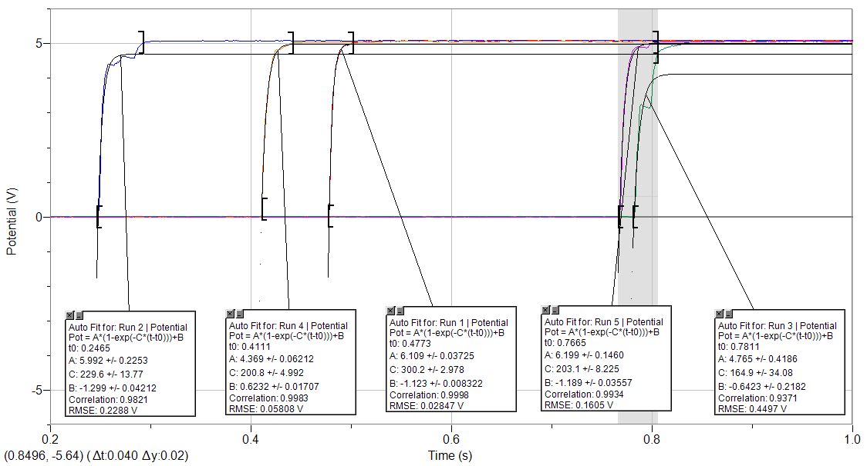

**Figure 3-1.** The set of sigmoid graphs for each run of measurements, using a configuration of a 10 Ω resistor and a 330 μF capacitor.

|  |  |  |  |  |  |
| --- | --- | --- | --- | --- | --- |
| 330 μF Capacitor & 10 Ω Resistor | | | | | |
| T-switch (s) | T-cross (s) | T ½ (s) | Tau (s) | Tau Curve Fit (s) | Error |
| 0.478 | 0.4805 | 0.0025 | 0.003606738 | 0.00333 | 7.67% |
| 0.249 | 0.251 | 0.002 | 0.00288539 | 0.00436 | 51.11% |
| 0.783 | 0.7865 | 0.0035 | 0.005049433 | 0.00606 | 20.01% |
| 0.411 | 0.414 | 0.003 | 0.004328085 | 0.00498 | 15.06% |
| 0.769 | 0.771 | 0.002 | 0.00288539 | 0.00492 | 70.51% |
|  |  |  |  | AVG | 0.00375101 |
|  |  |  |  | STDDEV | 0.00094052 |

**Table 3-1.** Expected (calculated) time constant for the 10 Ω – 330 μF configuration versus the measured time constant with error margins and deviation.

**330 μF Capacitor – 100 Ω Resistor**

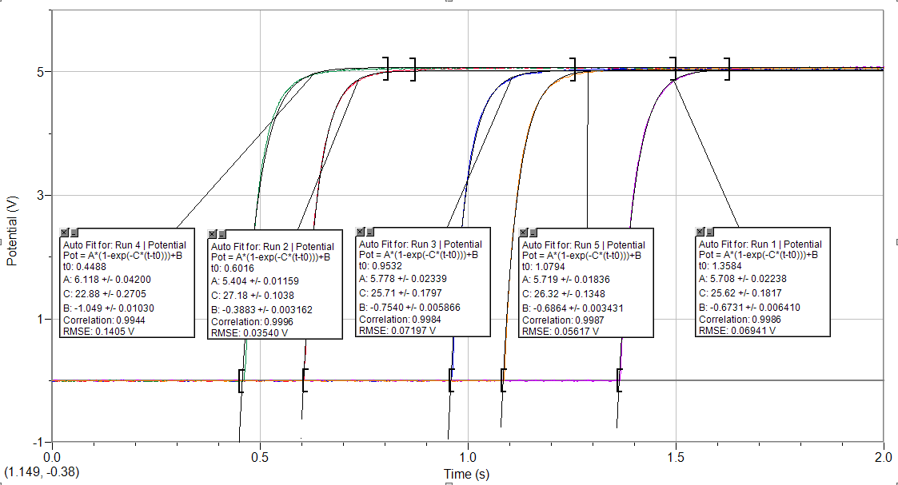

**Figure 3-2.** The set of sigmoid graphs for each run of measurements, using a configuration of a 100 Ω resistor and a 330 μF capacitor.

|  |  |  |  |  |  |
| --- | --- | --- | --- | --- | --- |
| 330 μF Capacitor & 100 Ω Resistor | | | | | |
| T-switch (s) | T-cross (s) | T ½ (s) | Tau (s) | Tau Curve Fit (s) | Error |
| 1.366 | 1.39 | 0.024 | 0.034624681 | 0.039 | 12.64% |
| 0.606 | 0.63 | 0.024 | 0.034624681 | 0.0368 | 6.28% |
| 0.961 | 0.986 | 0.025 | 0.036067376 | 0.0389 | 7.85% |
| 0.462 | 0.488 | 0.025 | 0.036067376 | 0.0437 | 21.16% |
| 1.087 | 1.111 | 0.024 | 0.034624681 | 0.038 | 9.75% |
|  |  |  |  | AVG | 0.03520176 |
|  |  |  |  | STDDEV | 0.0007902 |

**Table 3-2.** Expected (calculated) time constant for the 100 Ω – 330 μF configuration versus the measured time constant with error margins and deviation.

**100 μF Capacitor – 33 Ω Resistor**

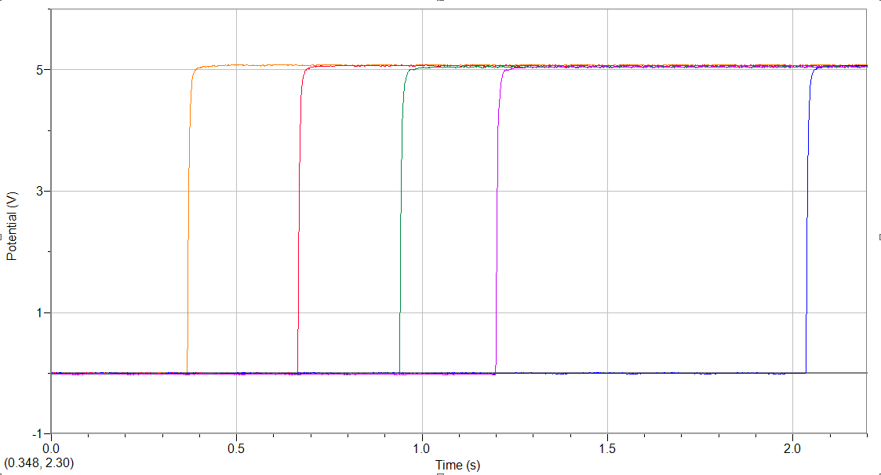

**Figure 3-3.** The set of sigmoid graphs for each run of measurements, using a configuration of a 33 Ω resistor and a 100 μF capacitor.

|  |  |  |  |  |  |
| --- | --- | --- | --- | --- | --- |
| 100 μF Capacitor & 33 Ω Resistor | | | | | |
| T-switch (s) | T-cross (s) | T ½ (s) | Tau (s) | Tau Curve Fit (s) | Error |
| 0.368 | 0.37 | 0.002 | 0.00288539 | 0.004 | 38.63% |
| 0.665 | 0.668 | 0.003 | 0.004328085 | 0.0035 | 19.13% |
| 2.035 | 2.039 | 0.004 | 0.00577078 | 0.0045 | 22.02% |
| 0.94 | 0.9425 | 0.0025 | 0.003606738 | 0.0047 | 30.31% |
| 1.199 | 1.2015 | 0.0025 | 0.003606738 | 0.0043 | 19.22% |
|  |  |  |  | AVG | 0.00403955 |
|  |  |  |  | STDDEV | 0.00109398 |

**Table 3-3.** Expected (calculated) time constant for the 33 Ω – 100 μF configuration versus the measured time constant with error margins and deviation.

**100 μF Capacitor – 100 Ω Resistor**

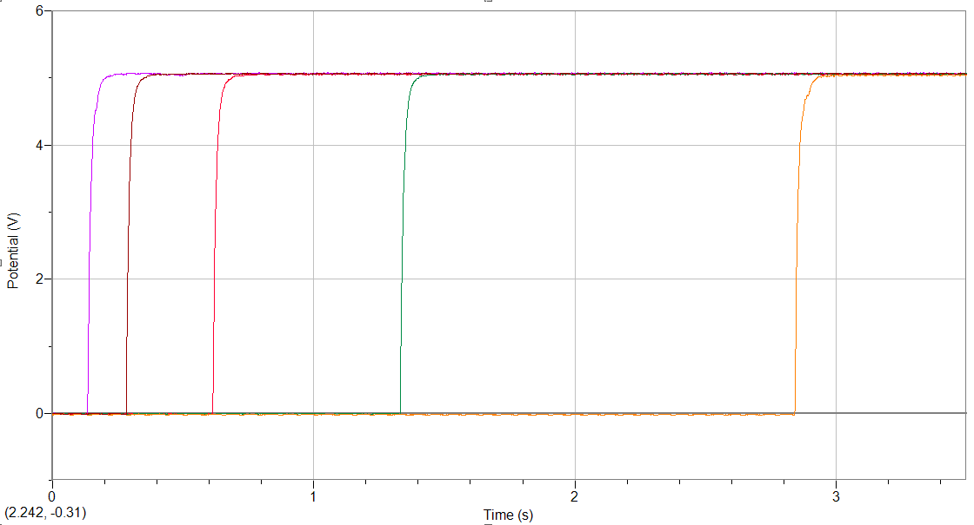

**Figure 3-4.** The set of sigmoid graphs for each run of measurements, using a configuration of a 100 Ω resistor and a 100 μF capacitor.

|  |  |  |  |  |  |
| --- | --- | --- | --- | --- | --- |
| 100 μF Capacitor & 100 Ω Resistor | | | | | |
| T-switch (s) | T-cross (s) | T ½ (s) | Tau (s) | Tau Curve Fit (s) | Error |
| 0.136 | 0.144 | 0.008 | 0.01154156 | 0.0139 | 20.43% |
| 0.615 | 0.623 | 0.008 | 0.01154156 | 0.0133 | 15.24% |
| 0.284 | 0.291 | 0.007 | 0.010098865 | 0.0127 | 25.76% |
| 1.332 | 1.34 | 0.008 | 0.01154156 | 0.0129 | 11.77% |
| 2.841 | 2.85 | 0.009 | 0.012984255 | 0.0135 | 3.97% |
|  |  |  |  | AVG | 0.01154156 |
|  |  |  |  | STDDEV | 0.00102014 |

**Table 3-4.** Expected (calculated) time constant for the 100 Ω – 100 μF configuration versus the measured time constant with error margins and deviation.

**Analysis**

The data for each set of runs has been presented such that the nature of each trial is clear. The LabPro graphs show the detail of each run, and the tables compare the time constant derived from a fit of the graph to that derived from the specific times at which the collection period started and reached the 2.5 Volt threshold. The results are consulted as follows:

**330 μF Capacitor – 10 Ω Resistor**

This set of runs demonstrates some significant behavior. The second run had an error margin of about 50%, while the final run had such of more than 70%. While the remaining error margins were more typical of that which will be seen in the following configurations, these still had a dramatic effect on the suitability of this collection of results. These high errors brought the standard deviation for the measurements to **0.00094052 s**. This means that, on average, we can expect at least a 25% deviation. Compared to the lowest-end deviation, that is more than 30% of the measured value. This is very surprising.

**330 μF Capacitor – 100 Ω Resistor**

This configuration’s results are more in line with what was expected. The highest error seen was 21% in the fourth run. There was also a 12% error in the first run. Overall, these errors are somewhat within the range of expectations and are not exemplified by all the runs for this setup. This is supported by the resultant standard deviation, which is in this case reasonable.

**100 μF Capacitor – 33 Ω Resistor**

The error margins for this set of runs were consistently high. However, unlike the other sets with large error margins, the magnitude of these discrepancies was very consistently within a mid-level range: All were in the range of about 20 % to 30 %.

**100 μF Capacitor – 100 Ω Resistor**

This set of trials also saw larger discrepancies between the expected measurements and the ones derived from the sigmoid graph. However, they average much lower than others. In fact, the standard deviation was determined to be less than ten percent of the average, which is significantly better than some of the other trials.

**Conclusions**

We have attempted to validate the effect on the intrinsic time constant of an RC circuit done by various configurations of resistance and capacitance. All runs produced consistent graph shapes in the LoggerPro software kit, though there were some brow-raising differences that appeared in the collected data. The first set of runs had the worst offending error margins, and the third was also somewhat horrid. Fortunately, there seems to be a predictable pattern.

When looking at the sigmoid graphs of most discrepant configurations, we can see that the graphs are much steeper and have much more sudden curves. This is foreseeable: the configurations that have a lower capacitance and/or a lower resistance will plateau faster. This is because circuits with a lower capacitance will reach capacity sooner and those with lower resistance will have a higher current (thus more charge for the capacitor). Because these configurations fill up faster, and the changes are so sudden, even the 1000 samples per second collection rate was not enough to keep up. The power fit on the Logger Pro software must be done manually, and the user selecting the range to fit to is limited to the discrete collection points. Depending on slight differences in the time of *tswitch* for each run, the graphs may not have accurately captured the rising voltage – or more specifically *when* it started rising. This leads to inexact measurements and therefore error.

Overall, when this pattern is considered, the results are consistent. The configurations that had the lowest resistance/capacitance combination also had the most error. Adjusted for that, the results match up to what we expect. While we may not have achieved the exact values desired, we can probably say safely that the data matches expectations and supports the theory.